SECONDARY INTEGRATION

1. TO UPLOAD BILL:

ADMIN OPTIONS TRANSACTION UPLOAD PRIMARY BILL

* Upload the given bill (Excel Sheet)

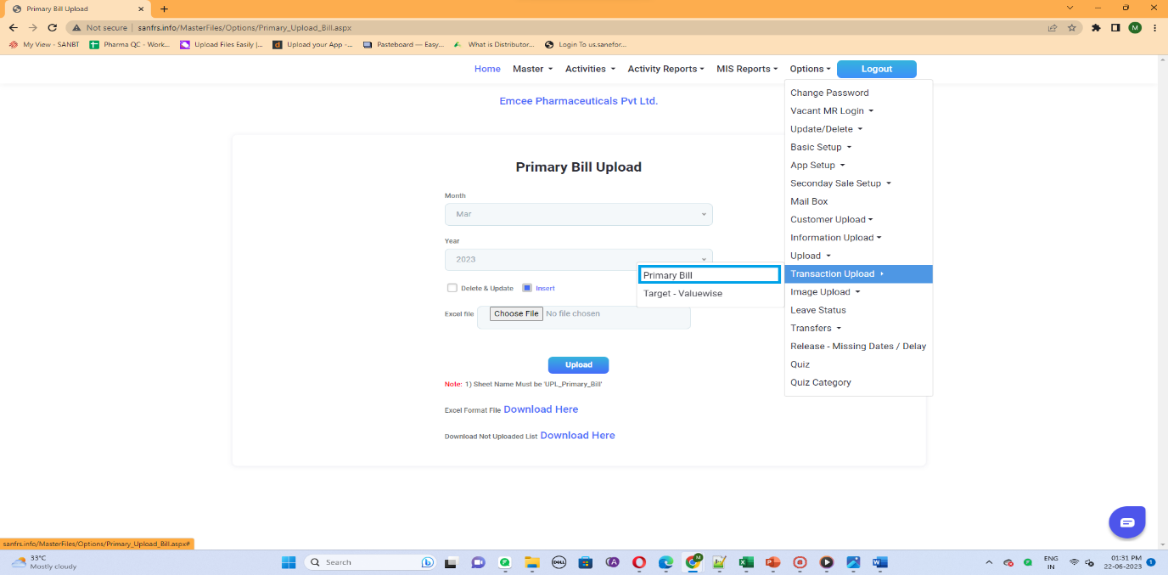

Image :How to upload Bill(i)

1. TO ENTER SECONDARY SALE ENTRY

* Login to MR user id and check whether Uploaded Stockist are Mapped to the User.
* BASE LEVEL LOGIN ACTIVITIES SECONDARY SALES ENTRY

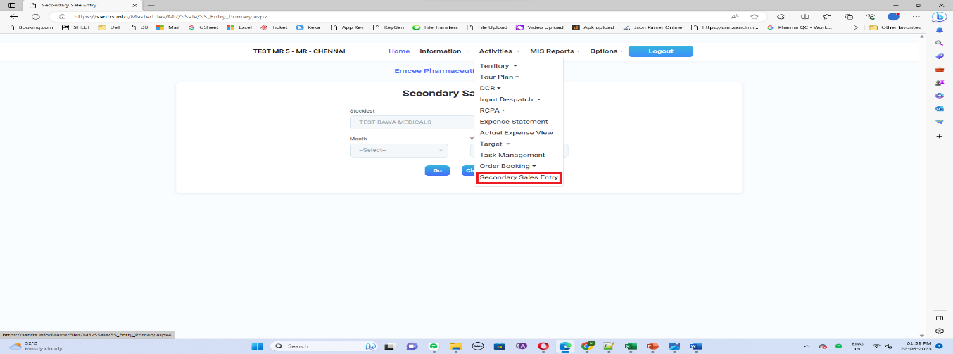

Image :How to Do SS Entry

* Choose the Stockist then Select the Month& Year and click go.

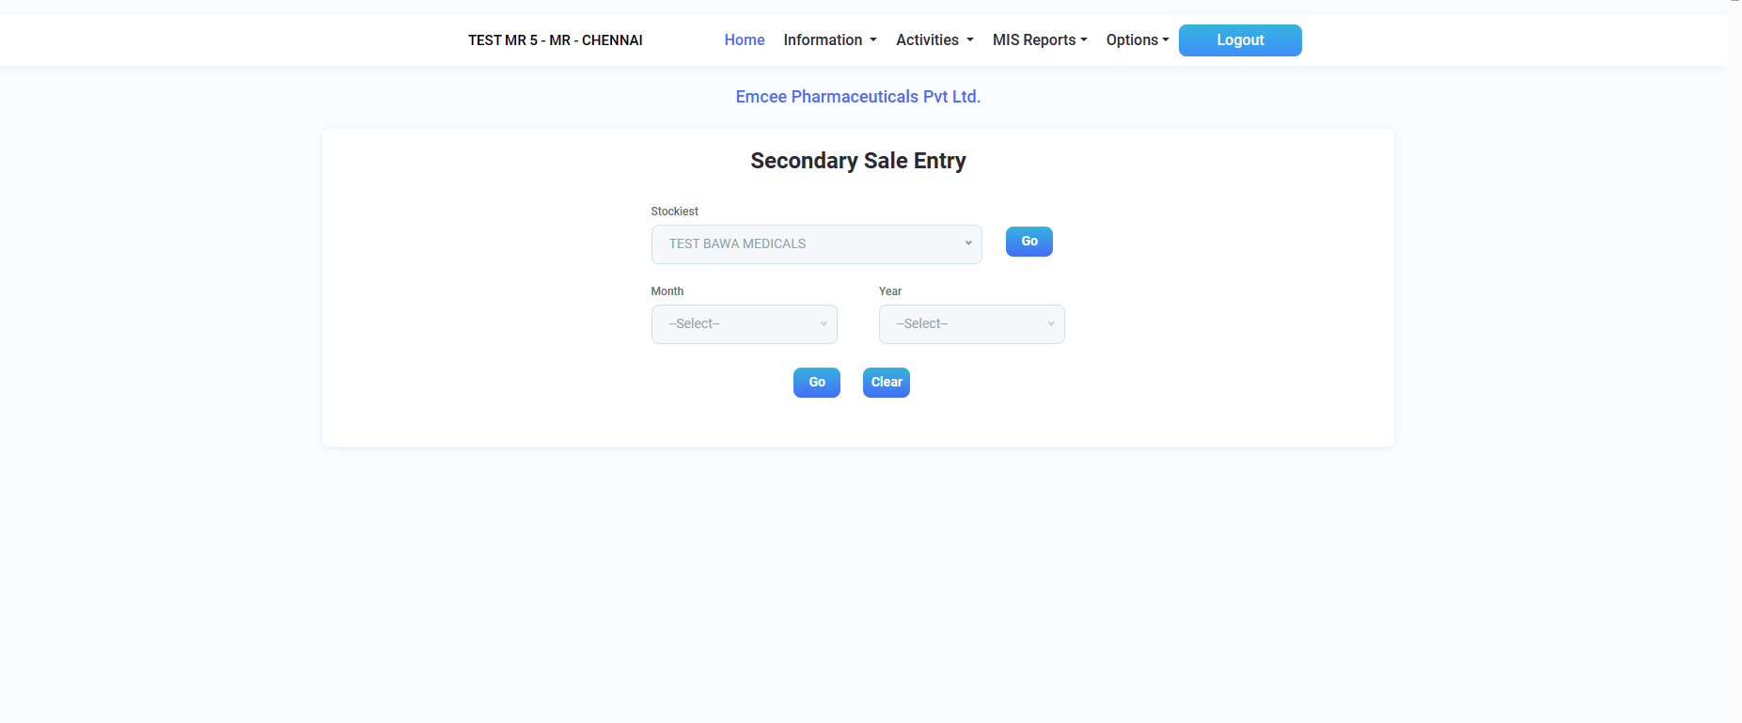

Image: Selecting Stockist

1. BILL DETAILS

* UPLOADED BILL DETAILS
  + - * Uploaded Bill for a mapped Stockist for the user will be displayed in the primary Bill details for the uploaded month.

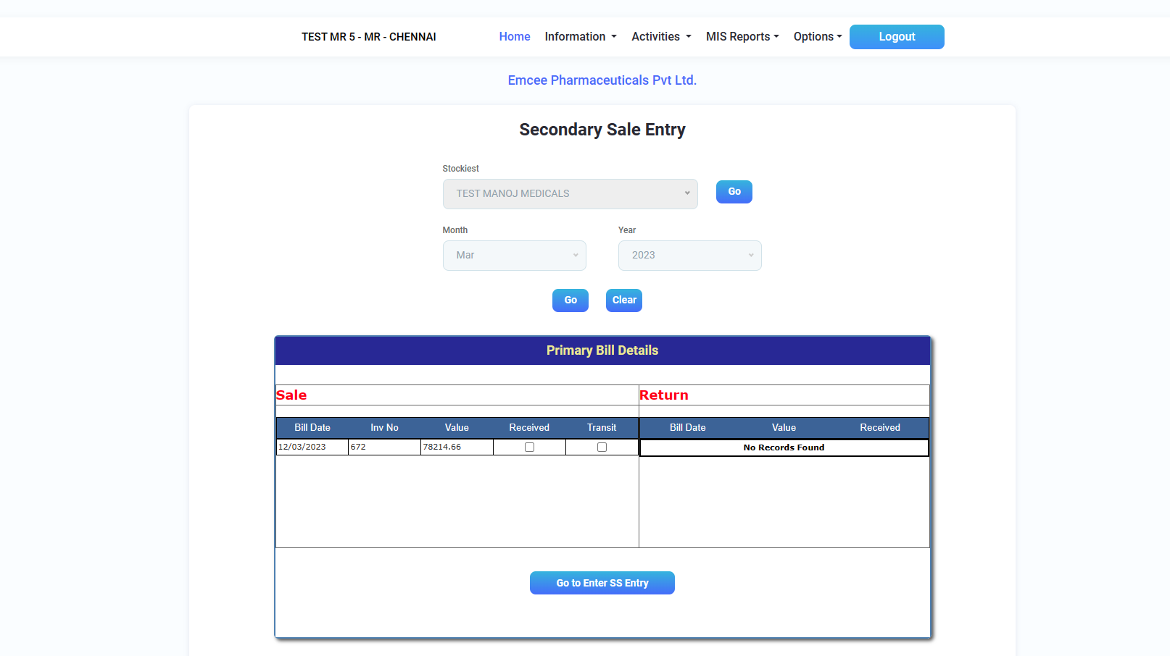

Image: Uploaded Bill Detail for Mapped Stockist

SALE Based on the Invoice number uploaded Product will be displayed

RECEIVED The User Received Product.

TRANSIT The User didn’t Receive the Product

RETURN The User Returned the Product (Not Available)

* Select Receive / Transit for the bill
* Click Go to SS Entry

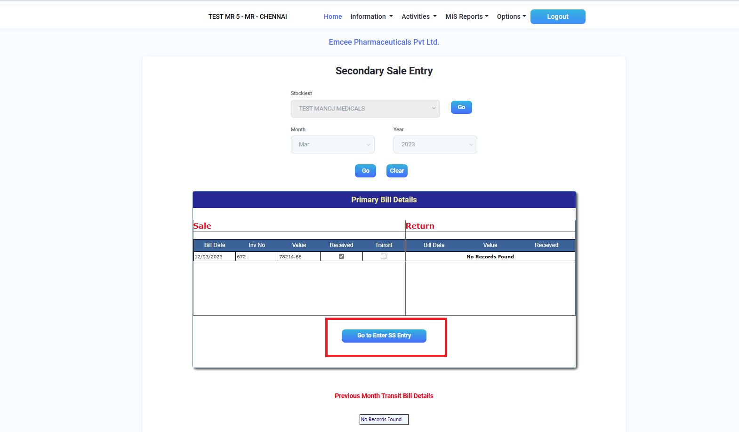

Image: Selecting Receive in Bill

* + - * In Bill, if we select Received, the following details have displayed shown as below.

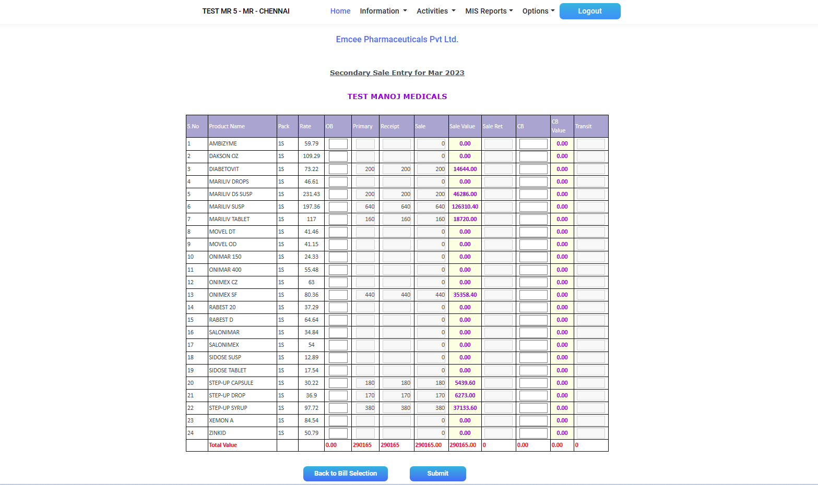

Image: To Enter Secondary Sale Entry

OB Opening Balance – In the First month the “Opening Balance” will be empty and enterable, from next month onwards previous month’s “Closing Balance” is next month’s “Opening Balance”

Primary Current Month Total Uploaded Product Qty

Receipt Current Month Received Product Qty & Previous Month Transit Qty

CB Closing Balance – At the End of the month Available balance after the Sale.

Sale Qty (Opening Balance + Receipt) – Closing Balance

Rate Rate for the Product which was uploaded by the Admin

Sale Value Rate \* Sale Qty

CB value Rate \* CB

Transit Current Month Transits to Next Month

* + - * Click Submit after Entering the values

Note:

* Once Secondary sales are submitted for a month, then unable to select Previous Month
* If we submitted for a month, then next month bills were displayed sequentially.
* In bill, if we select Transit, the following details have displayed shown as below.

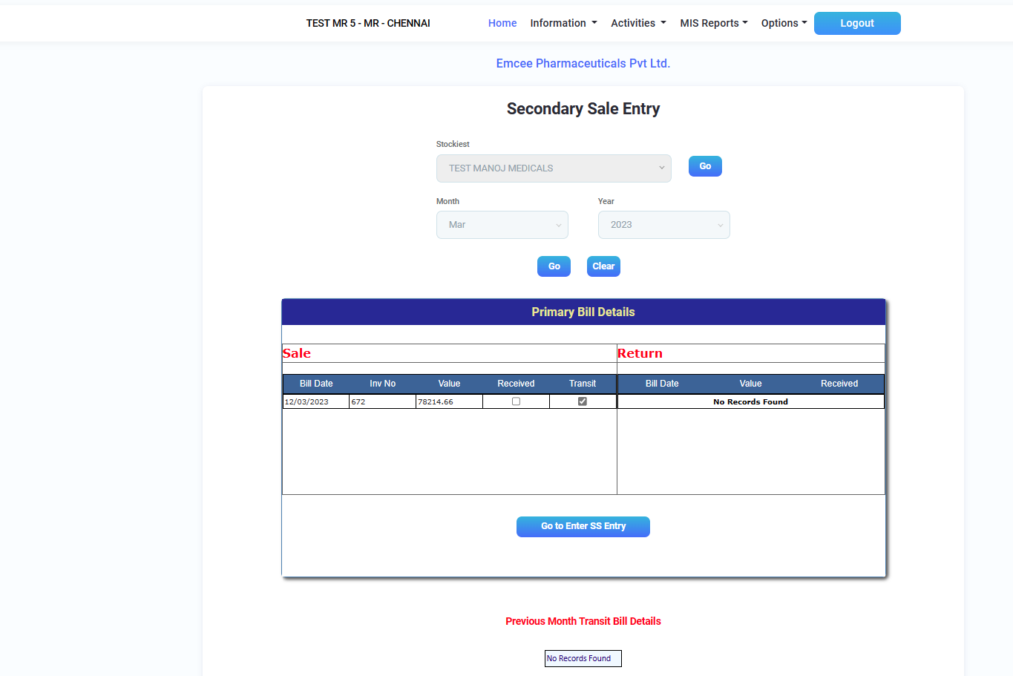

Image: Selecting Transit in Bill

* Select Transit and Click Go to Enter SS Entry

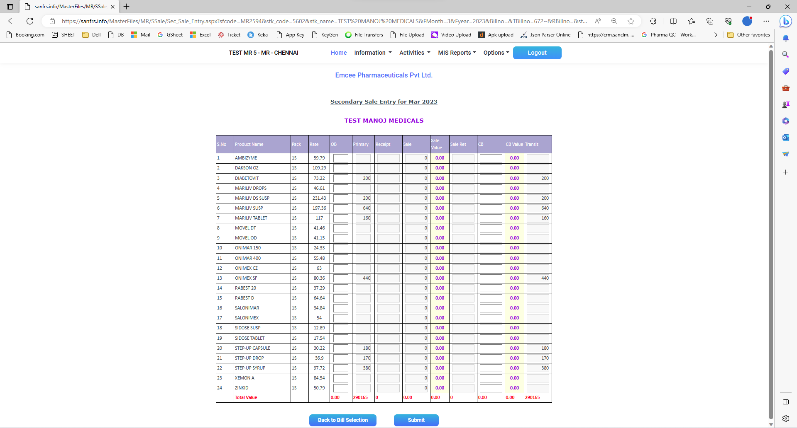

* Then Receipt Value was displayed as Empty and Transit Value was Filled
* Click Submit
* After Submitted Transit Bill, in Primary Bill page it displayed Previous Month Transit Bill Details

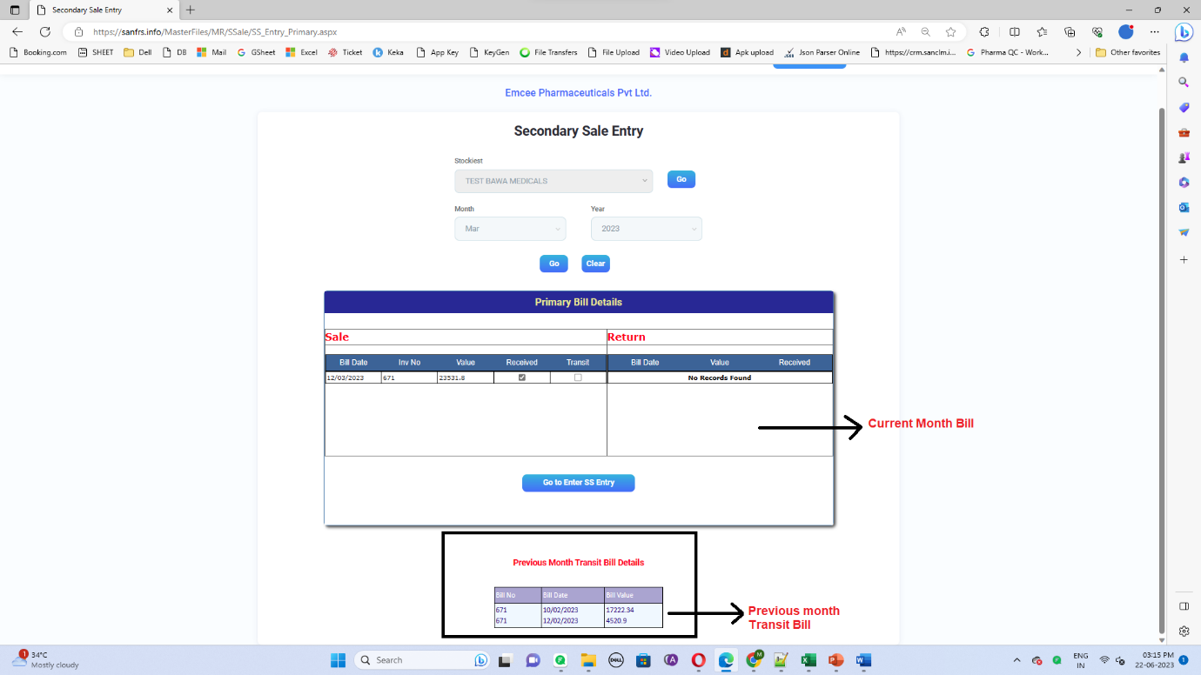

* NOT UPLOADED BILL
* If Bill was Not uploaded then that month, it was displayed as No Bill

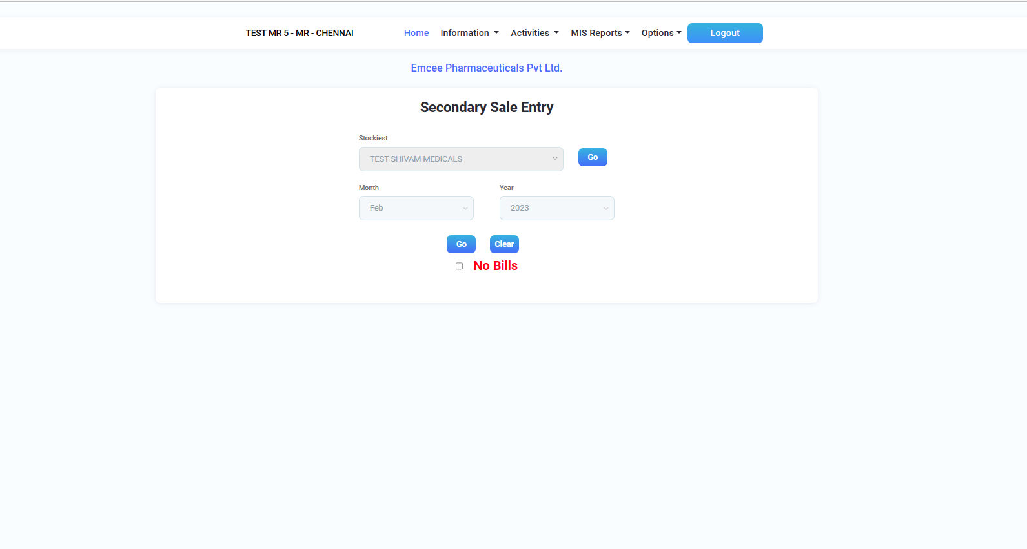

Image: Bill Not Uploaded Month

* If we click No Bills then all Products are displayed

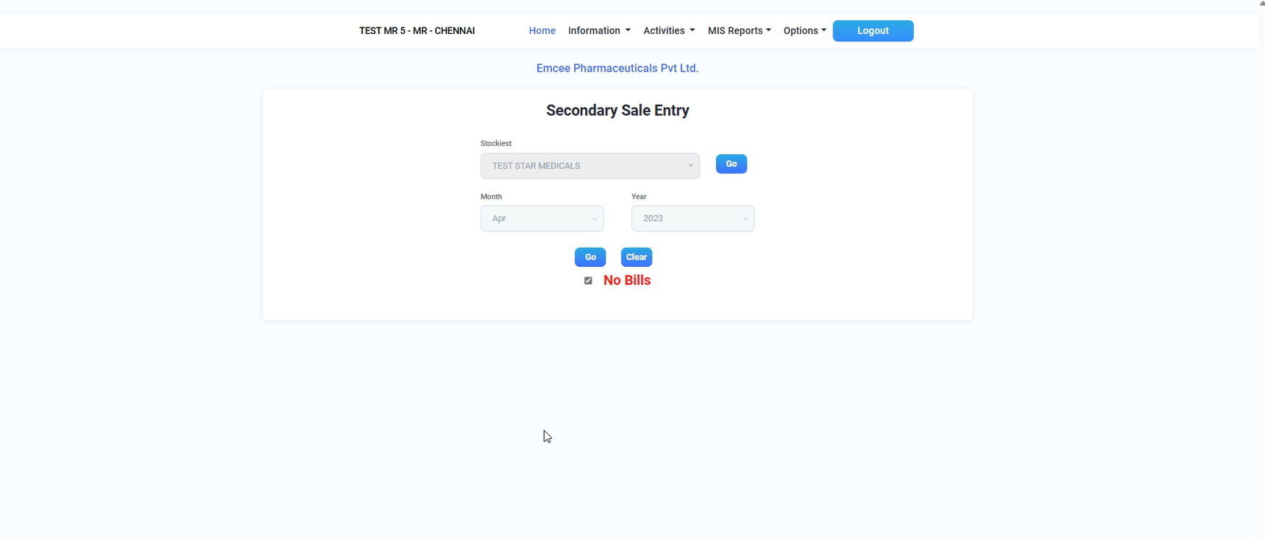

Image:Clicking No Bills

* While Clicking No Bills it will be automatically displayed all products

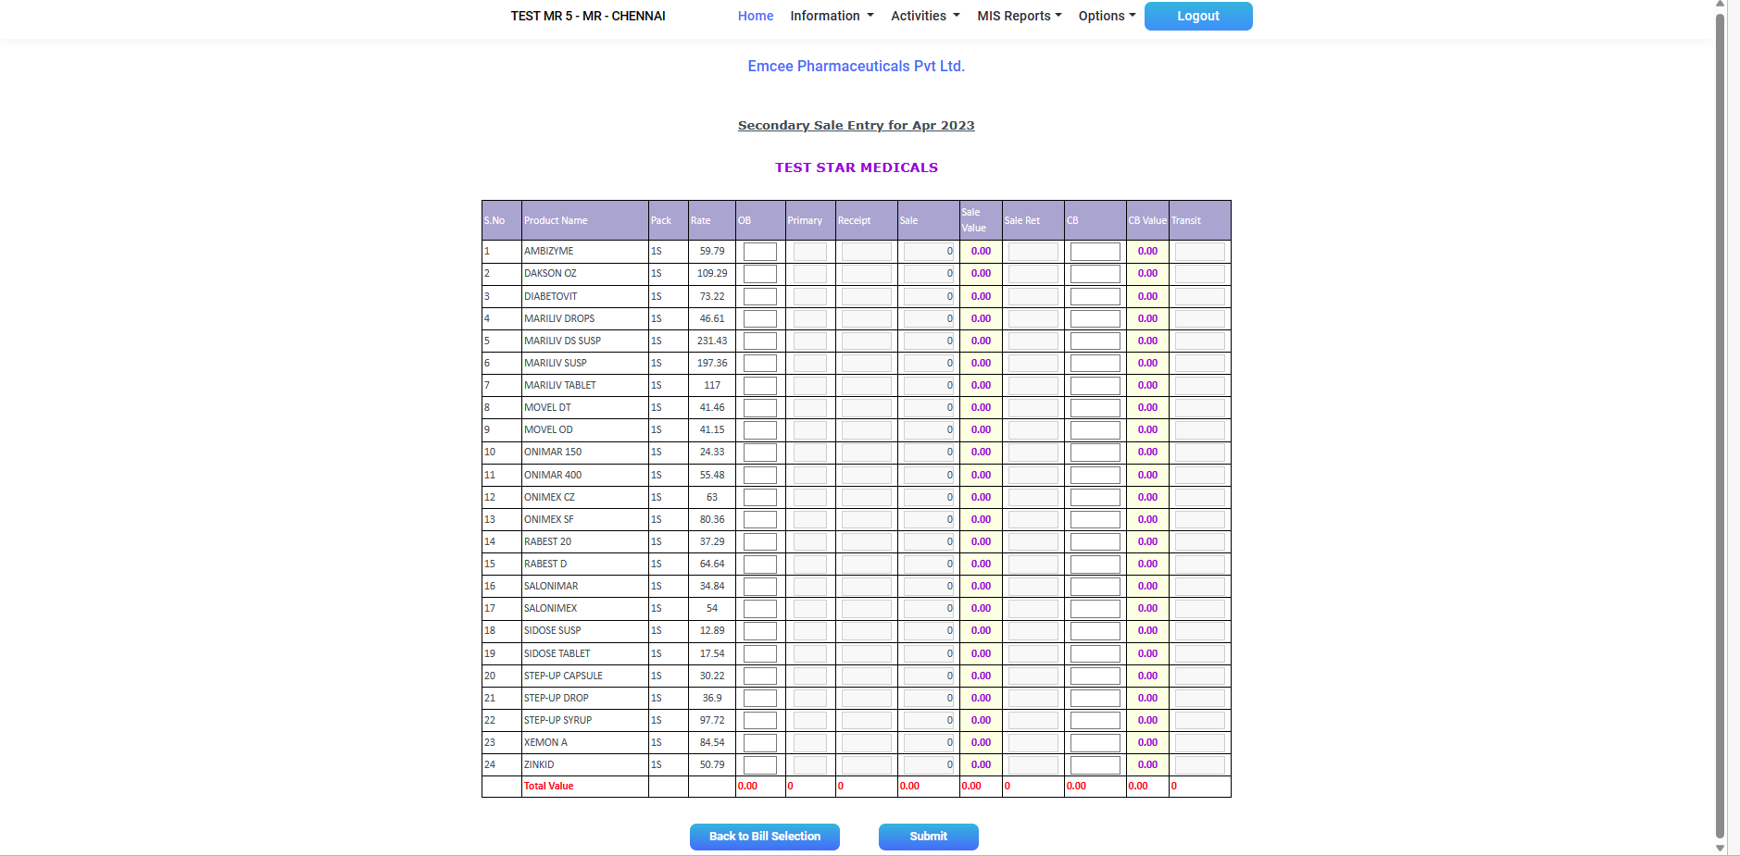

* After Clicking No Bills the Product value will be empty and should be Enterable
* After Entering Values Click Submit

1. TO VIEW SUBMITTED BILL

* Login to ADMIN Id MIS REPORT DUMP SECONDARY SALE

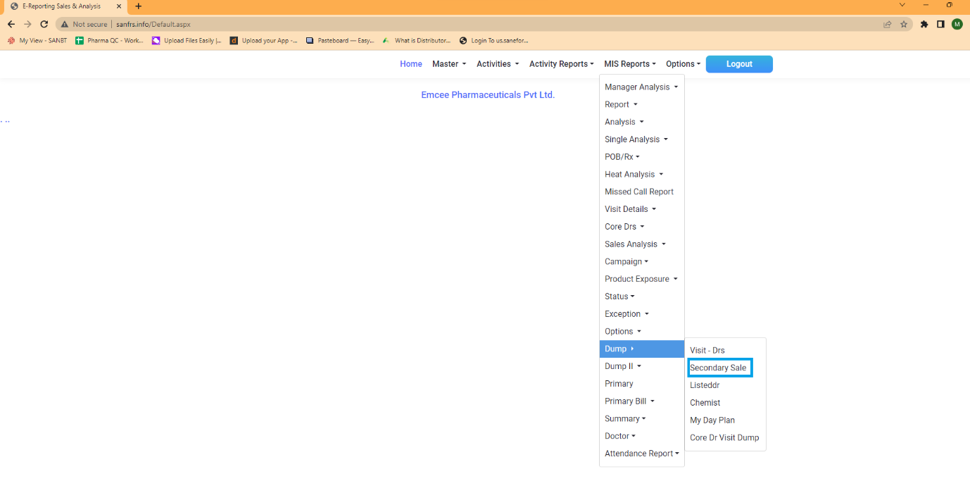

Image: To View Submitted Bill

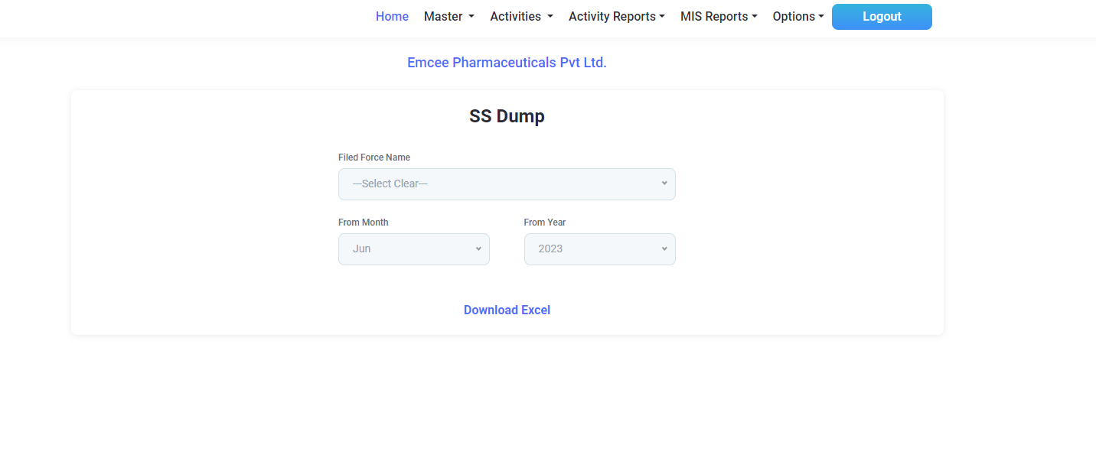

* Select the Field Force Name and choose the Month to View Submitted Bill